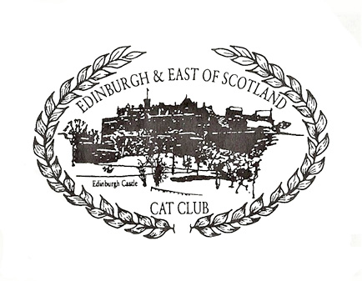
EDINBURGH & EAST OF SCOTLAND CAT CLUB

RENEWAL MEMBERSHIP FORM

I/we wish to renew membership of the Edinburgh & East of Scotland Cat Club.

I/We agree to abide by the rules of the Club and those of the GCCF.

The Edinburgh & East of Scotland Cat Club will store and use your personal data for the purposes of administering the club and your involvement in club activities. The data will be collected and processed in accordance with the Edinburgh & East of Scotland Cat Club Privacy Policy.
I/we understand that by submitting this form I am consenting to my data being used in this way.

Title, First Name & Surname
2nd person details if Joint
Title, First Name & Surname
Home Address
Post Code
Home Telephone Number
Mobile Number
Email Address
Age (if under 16)

Signature: _________________________________ Date: _____________________

ANNUAL MEMBERSHIP FEE (Payable every January)
Single: £5.00 Senior Citizen: £3.00 Joint: £7.50 Junior: £2.00

Please provide details: Are you a breeder? Which breeds (pedigree, pet cats or both)? Do you keep any stud cats in these breeds? Do you have a Prefix? Are you interested in joining the Committee? Will you be showing your cats at our annual cat show? Are you interested in volunteering at the show?

Please email the completed renewal form to Alex Anderson on aaat10@blueyonder.co.uk
Bank Transfer payments to (Please note your name & ‘SUBS’ in the Reference):
Bank of Scotland, Sort Code: 801742, Account Number: 00858848
Cheques made payable to: Edinburgh and East of Scotland Cat Club
Post to:
Mr Alex Anderson, Treasurer & Membership Secretary, Rockville, Arthur Avenue, Cairnhill, Airdrie ML6 9EZ

